**North South University**

**Department of Electrical and Computer Engineering**

**CSE 215L: Programming Language II Lab**

**Lab** – **6: Class & Object**

**Objective:**

* To learn about class and objects
* To learn to implement a class using UML

**Task:**

Implement the following class and test its methods:

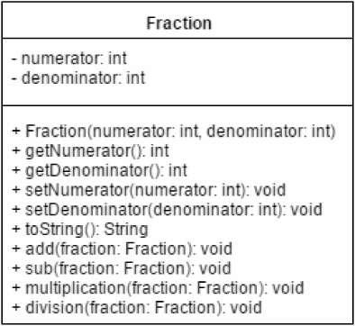

***void add(Fraction fraction)***

Adds two Fraction objects and **stores the result** into **calling object**. This is how addition is performed for fractions:

1/4+3/5= 1*5+3*4/4*5=17/20

***String toString()***

Returns the value of the fraction in 1 / 2 format where 1 is numerator and 2 is denominator.

Now write a test program, take two Fraction objects. Print both of them. Test add, sub, multiplication and division methods. Print calling object after each method call.